IS5306: NUMERICAL METHODS

TAKE HOME ASSIGNMENT 1

NAME : SENANAYAKE S.P.G.A

REG No. : EG/2020/4199

SEMESTER : 05

DATE : 06/02/2024

Bisection Method

Q) Finding the root of $f\left(x\right)={2x}^{3}-2x-5$ by using the Bisection method, Let the starting intervals be [1, 2] and the error is $ε_{n}=0.001$

$$f\left(x\right)={2x}^{3}-2x-5$$

$f\left(1\right)=-5$ $f\left(2\right)=7$

$f\left(1\right) f\left(2\right)<0$, has opposite signs.

So, we can use the bisection method to find the root, as $f\left(x\right)$ has at least one root in between 1 and 2.

|  |  |  |  |  |  |  |  |  |  |
| --- | --- | --- | --- | --- | --- | --- | --- | --- | --- |
| a | b |  | |  |  | | --- | --- | | |  | | --- | |  | | | | |  |  | Update | New b-a |
| 1 | 2 | -5 | 7 | 1.5 | -1.25 | $a_{1}$ =1.5 | 0.5 |
| 1.5 | 2 | -1.25 | 7 | 1.75 | 2.21875 | $b_{2}$ =1.75 | 0.25 |
| 1.5 | 1.75 | -1.25 | 2.21875 | 1.625 | 0.33203 | $b_{3}$ =1.625 | 0.125 |
| 1.5 | 1.625 | -1.25 | 0.33203 | 1.5625 | -0.49561 | $a_{4}=$ 1.5625 | 0.0625 |
| 1.5625 | 1.625 | -0.49561 | 0.33203 | 1.59375 | -0.09113 | $a_{5}=$ 1.59375 | 0.03125 |
| 1.59375 | 1.625 | -0.09113 | 0.33203 | 1.60938 | 0.1181 | $b_{6}=$ 1.60938 | 0.01563 |
| 1.59375 | 1.60938 | -0.09113 | 0.1181 | 1.60156 | 0.0129 | $b_{7}=$ 1.60156 | 0.00781 |
| 1.59375 | 1.60156 | -0.09113 | 0.0129 | 1.59766 | -0.03926 | $a_{8}=$ 1.59766 | 0.0039 |
| 1.59766 | 1.60156 | -0.03926 | 0.0129 | 1.59961 | -0.01322 | $a_{9}=$ 1.59961 | 0.00195 |
| 1.59961 | 1.60156 | -0.01322 | 0.0129 | 1.60059 | -0.00017 | $a_{10}=$ 1.60059 | 0.00097 |

Then $m_{1}=\frac{1+2}{2}=1.5$

$$f\left(m_{1}\right)={2×1.5}^{3}-2×1.5-5$$

= -1.25

Thus, with the tenth iteration, we note that the final interval, [1.59961,1.60156] has a width less than 0.001. Therefore, we choose **α=1.60059** to be our approximation of the root.

Matlab Code

function EG_2020_4199()

f = @(x) 2*x^3 - 2*x -5;%Function

a = 1;% Lower Range

b = 2;% Upper Range

error = 0.001;

fprintf('%-10s%-15s%-15s%-15s%-15s\n', 'Iteration', 'a', 'b', 'mid', 'Error');

fprintf(' -----------------------------------------------\n');

iteration = 0;

while (b - a) / 2 > error

mid = (a + b) / 2;

error = (b - a) / 2;

fprintf('%-10d%-15.6f%-15.6f%-15.6f%-15.6f\n', iteration, a, b, mid, error);

if f(mid) == 0

break;

elseif f(a) * f(mid) < 0

b = mid;

else

a = mid;

end

iteration = iteration + 1;

end

fprintf(' -----------------------------------------------\n');

fprintf('Root found at x = %.6f\n', (a + b) / 2);

% Plotting the graph of a vs f(a)

figure;

fplot(f, [-5, 5]);

hold on;

plot(a, f(a), 'ro', 'MarkerSize', 10); % Highlighting the final point

xlabel('X');

ylabel('f(X)');

title('Graph of X vs f(X)');

legend('f(x) = 2*x^3 - 2*x -5', 'Final point');

grid on;

end

Matlab Results

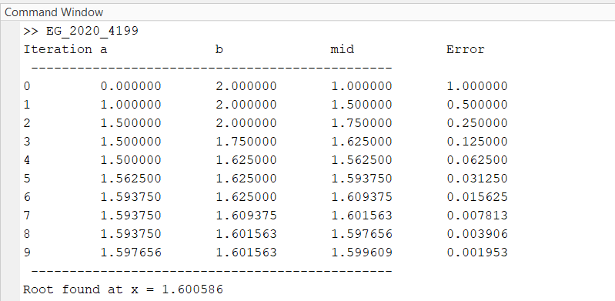

Figure 1:Matlab Results

Matlab Graph

Figure 2:Matlab Graph